# **Outlook is not Opening Test**

**Update Outlook**:

1. To enable automatic updates for **Outlook**, select **File** > **Office Account**.
2. Select **Update Options** and then select **Enable updates** in the drop-down menu.
3. 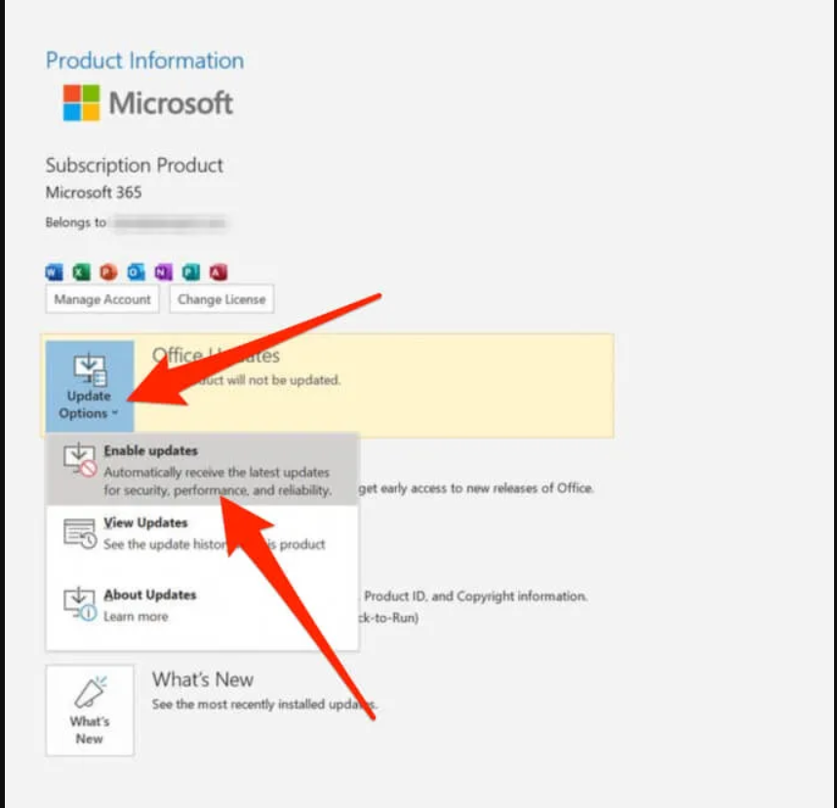
4. To check for and apply updates manually to Outlook, select **File** and then select **Office Account** in the navigation pane.
5. Select **Update Options** > **Update Now**.

#### **Check Outlook Mail Server Settings:**

1. Select **File** > **Account Settings** > **Account Settings**.
2. 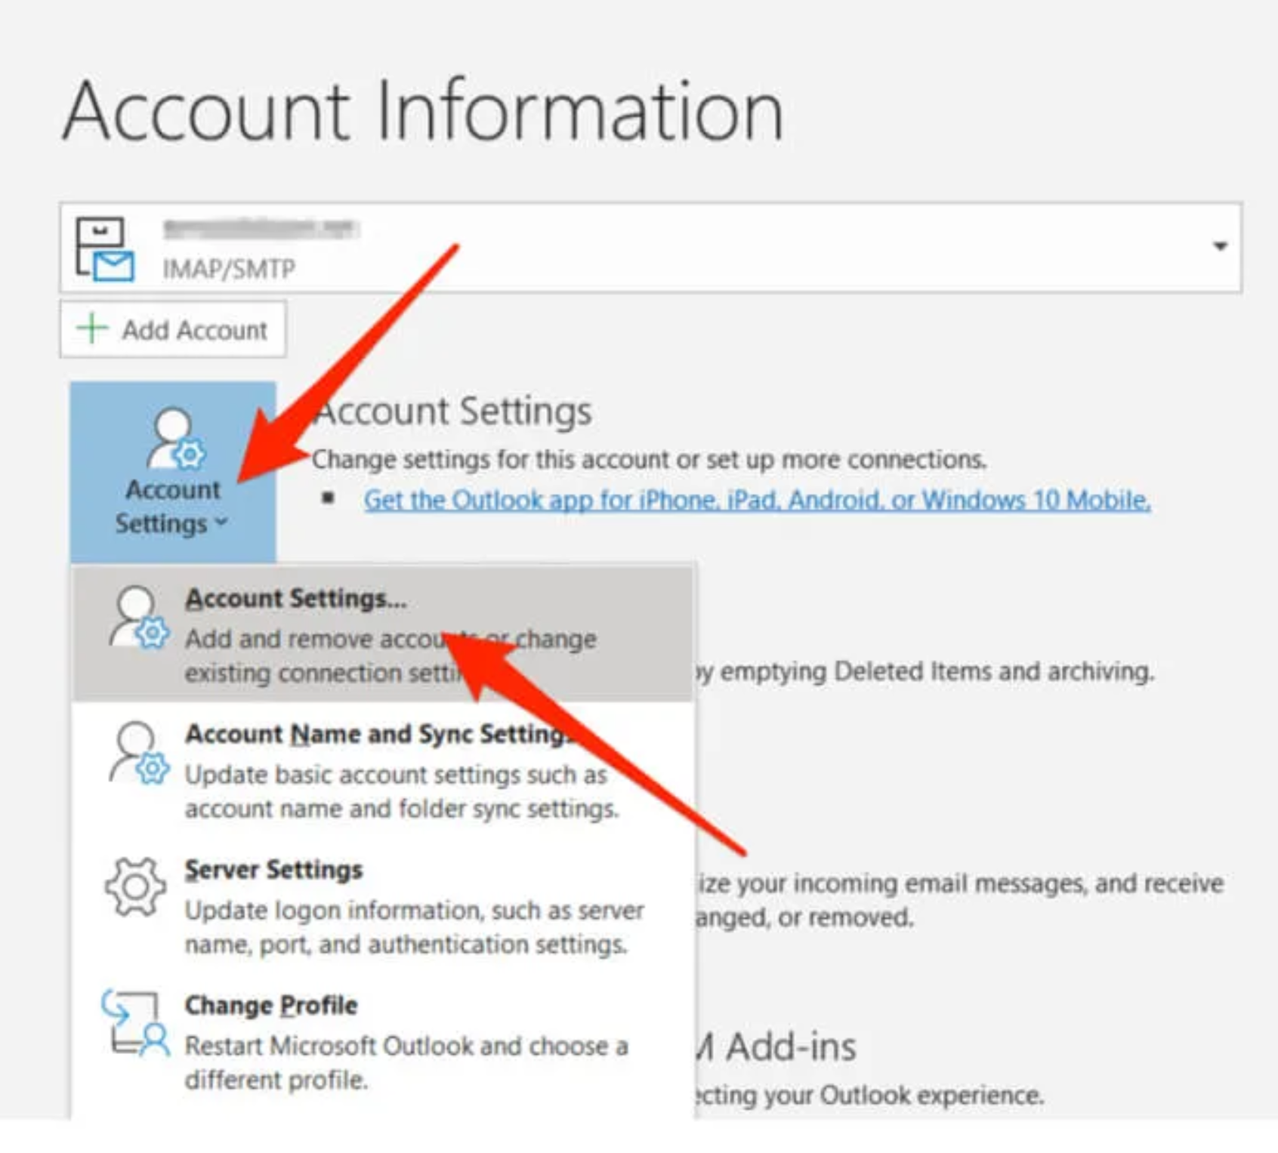
3. Next, select your **email** and then select **Change**.
4. 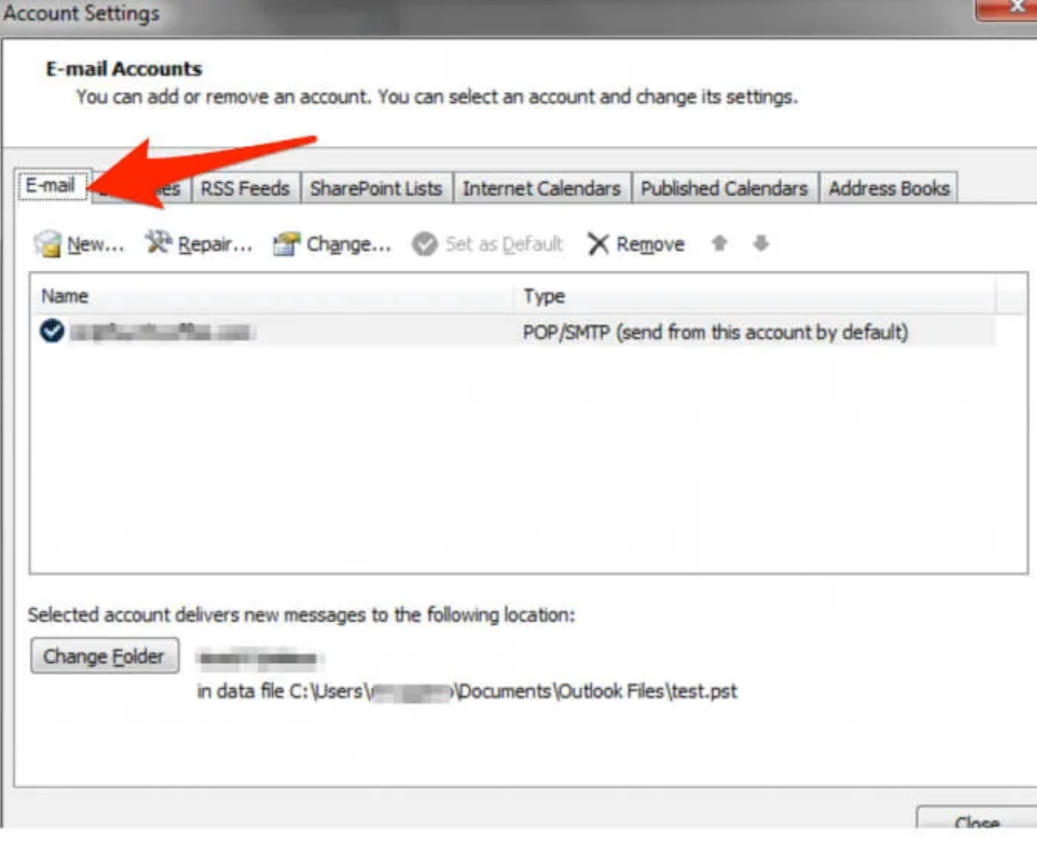

#### **Start Outlook in Safe Mode:**

1. Select **Start** > **Run**, type **Outlook /safe**, and then select **OK**.
2. Accept the default Outlook setting in the **Choose Profile** dialog box and then select **OK**.
3. 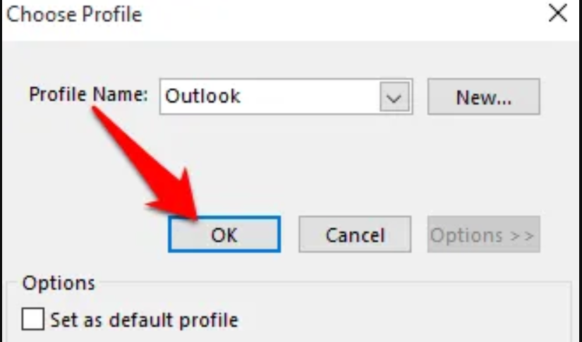
4. Enter your password if prompted and then select **Accept**. You’ll see the **Safe Mode** label next to your email address when Outlook is in Safe Mode.
5. if Outlook works when in Safe Mode, disable all your add-ins and then restart the app
6. To disable add-ins in Outlook, select **File** > **Options** > **Add-ins**.
7. Check whether the **Manage** box at the bottom of the **View and Manage Office Add-ins** shows **COM Add-ins**.
8. 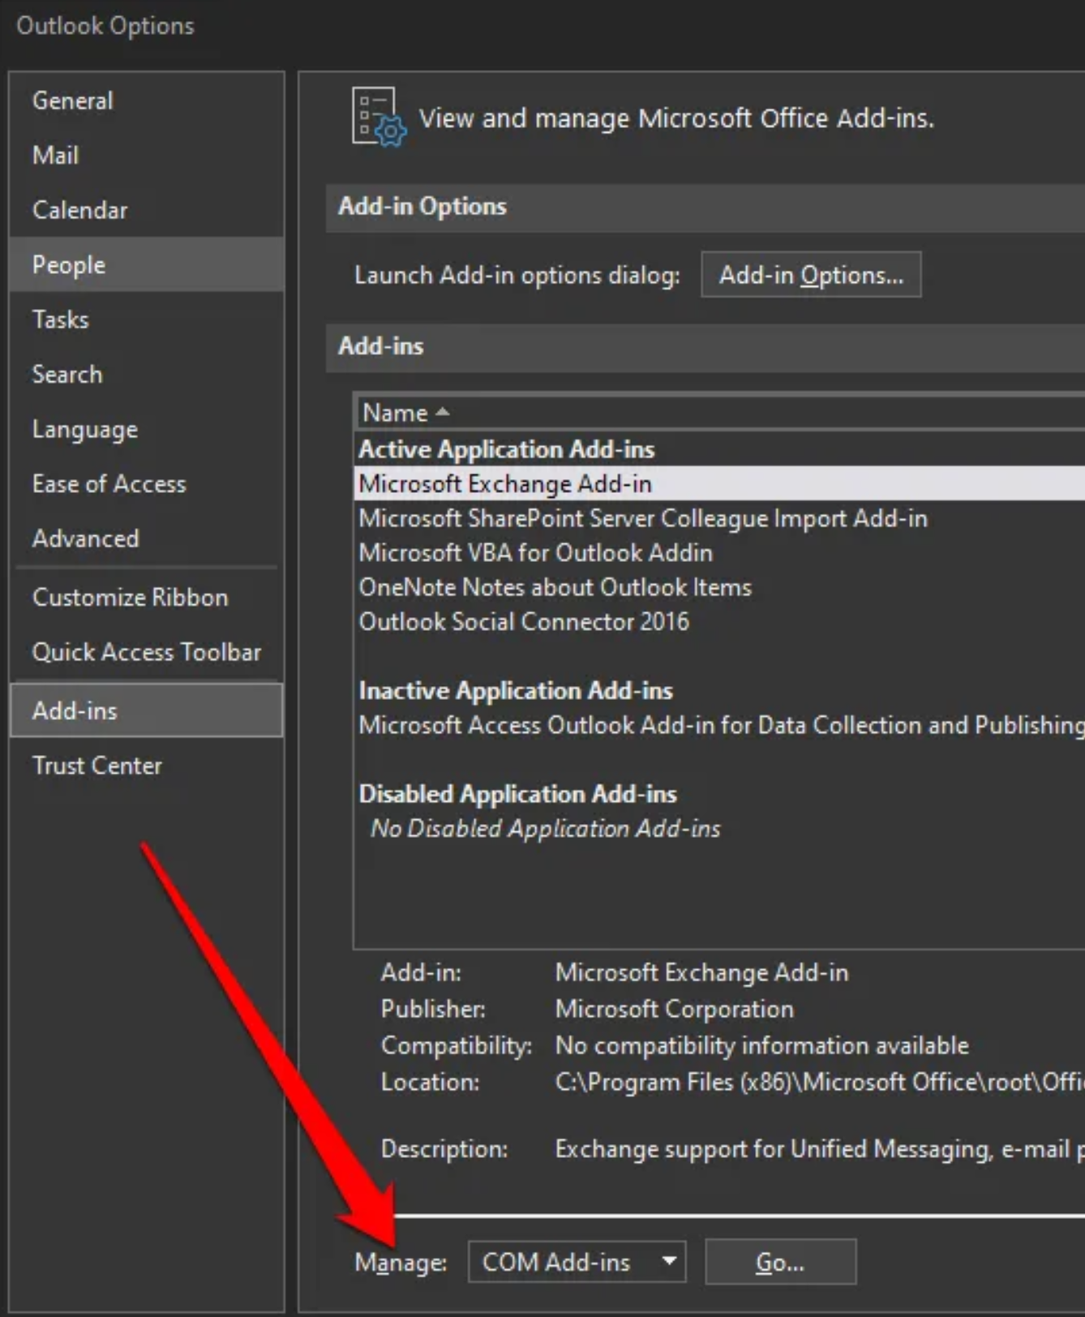
9. Select **Go**
10. If the **COM Add-ins** listing opens, take a screenshot of the property sheet and save the image or record each selected add-in listed under **Available Add-ins**. Once this is done, clear all the selected check boxes and then select **OK**.
11. 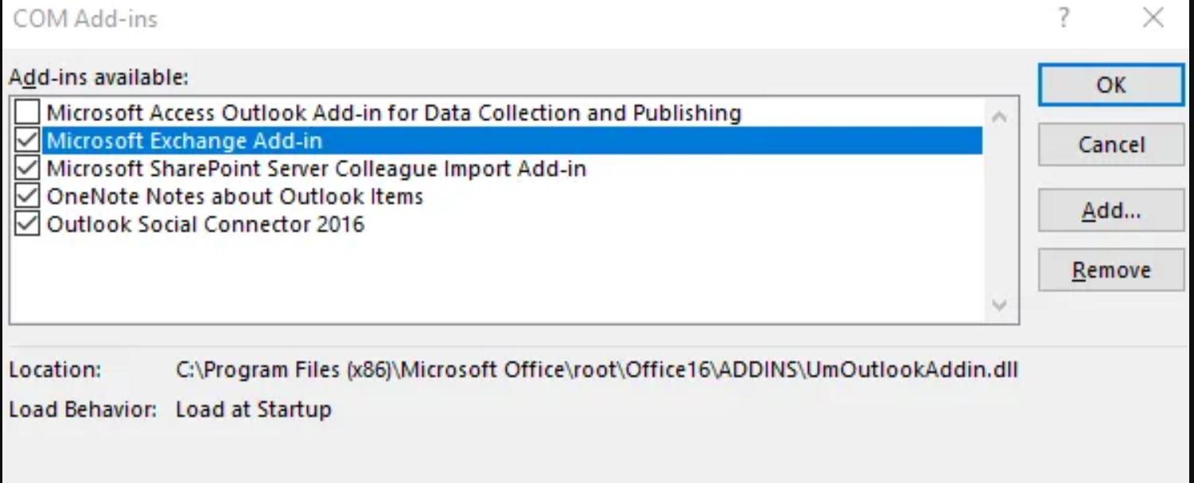
12. Select **File** > **Exit**, right-click **Start** > **Run**, type **Outlook** in the box and press **Enter**.
13. Next, select **File** > **Options** > **Add-ins**.

#### **Check if Outlook is Running in Compatibility Mode:**

1. Find the **Outlook.exe** file on your computer by going to **C:\Program Files\Microsoft Office\Office 14\ or C:\Program Files (x86)\Microsoft Office\Office 14\** on Outlook 2010 or **C:\Program Files\Microsoft Office\Office 15\ or C:\Program Files (x86)\Microsoft Office\Office 15\** for Outlook 2013.
2. Right-click the file and select **Properties** > **Compatibility** tab.
3. 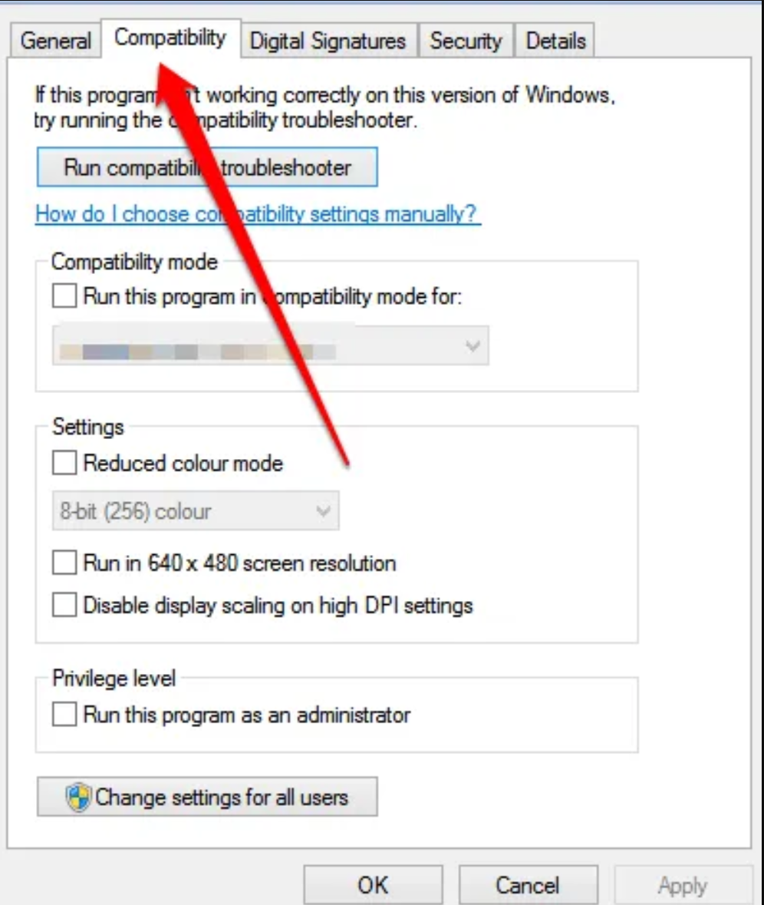
4. Uncheck any boxes that are checked on the **Compatibility** tab and then select **Apply** > **OK**. Restart Outlook and see if Outlook opens normally again.